**DAILY ONLINE ACTIVITIES SUMMARY**

|  |  |  |  |  |  |  |  |  |
| --- | --- | --- | --- | --- | --- | --- | --- | --- |
| **Date:** | **30-05-2020** | | | | | **Name:** | **Deeksha D Poojary** | |
| **Sem & Sec** | **VIII Semester & A Section** | | | | | **USN:** | **4AL16CS026** | |
| **Online Test Summary** | | | | | | | | |
| **Subject** | | **No Test was Conducted** | | | | | | |
| **Max. Marks** | | **-** | | **Score** | | | **-** | |
| **Certification Course Summary** | | | | | | | | |
| **Course** | **Introduction to Hadoop** | | | | | | | |
| **Certificate Provider** | | | **Great Learning** | | **Duration** | | | **4 Hours** |
| **Coding Challenges** | | | | | | | | |
| **Problem Statement: Find the number that is missing from the array containing n distinct number taken from 0,1,2....n.** | | | | | | | | |
| **Status: COMPLETED** | | | | | | | | |
| **Uploaded the report in Github** | | | | | **YES** | | | |
| **If yes Repository name** | | | | | **deekshapoojari** | | | |
| **Uploaded the report in slack** | | | | | **YES** | | | |

Online Test Details:

NIL

Certification Course Details:



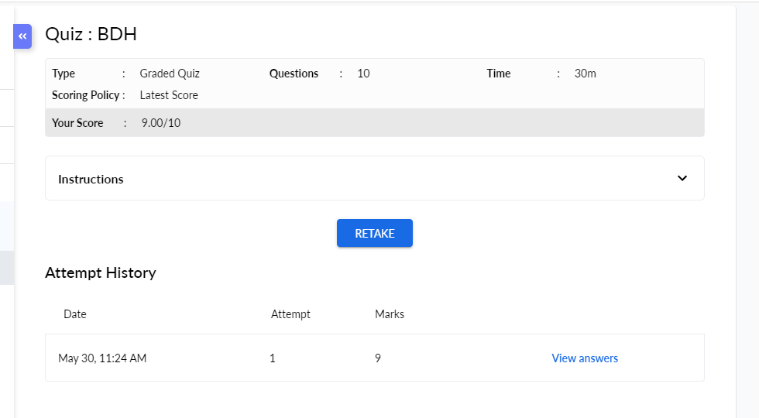



Coding Challenges Details:

|  |
| --- |
|  |
|  |
|  |
|  |
|  |
|  |
|  |
|  |
|  |
|  |
|  |
|  |
|  |
|  |
|  |
|  |
|  |
|  |
|  |
|  |
|  |
|  |
|  |
|  |
|  |
|  |
|  |
|  |
|  |
|  |
|  |
|  |
|  |
|  |
|  |
|  |
|  |
|  |
|  |
|  |
|  |
|  |
|  |
|  |
|  |
|  |
|  |
|  |
|  |
|  |
|  |
|  |
|  |
|  |

**Program1:**

|  |
| --- |
| **#include<stdio.h>** |
|  | **int getMissingNo(int a[], int n)** |
|  | **{** |
|  | **int i, total;** |
|  | **total = (n + 1) * (n + 2) / 2;** |
|  | **for (i = 0; i < n; i++)** |
|  | **total -= a[i];** |
|  | **return total;** |
|  | **}** |
|  | **int main()** |
|  | **{** |
|  | **int a[] = { 1, 2, 4, 5, 6 };** |
|  | **int miss = getMissingNo(a, 5);** |
|  | **printf("%d", miss);** |
|  | **getchar();** |
|  | **}** |